- Purpose

The purpose of this procedure is to describe how to determine the particle size of slurry product.

- Scope

This procedure applies to all in-coming slurry products to the QA Laboratory.

- Responsibility

Lab Associate is responsible for testing all slurry products.

- Safety Considerations

Appropriate PPE is to be worn in the laboratory.

Safety is a condition of employment. Employees are not authorized to work in an unsafe manner and are prohibited from harming the environment of the facility or the community.

- Materials/Equipment

- Computer – Optiplex 745
- Particle size analyzer – Cilas 1064
- Flosperse 9000
- 2 – 3 ml Droppers
- 15 mL Nalgene™ lowboy of DI water, piped into analyzer, with pressurizing bulb
- 1 Gallon carboy – catch vessel

- Procedure

Record the following data on forms Slurry Testing (L12-FM-200-009) or Tetra Slurry Testing (L12-FM-200-010).

- After recording data from slurry sample bottle shake sample until all settling has re-suspended.
- Turn on computer, monitor, and Cilas 1064.
- Double click on the Size Expert shortcut.
- Open the Measurement Settings window by clicking on the Measuring Icon  in the tool bar.
- Fill the sample chamber of the Cilas 1064 with water by opening the filling water inlet electrovalve in the Mimic Panel window:

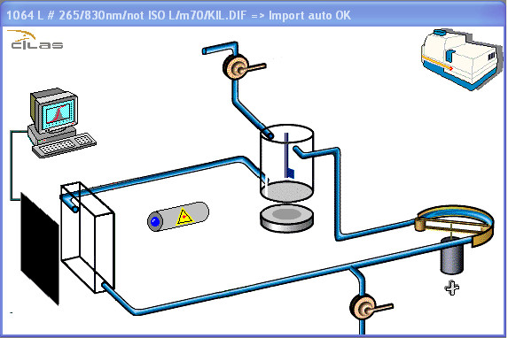
Filling water
inlet electrovalve
Agitator
Peristaltic circulation pump
Ultrasound generator
Drainage electrovalve

If the water does not begin to flow or is flowing too slowly, pump the pressurizing bulb until proper flow is achieved. If the water level in the lowboy is too low, then refill the lowboy and repeat step 5. Once the sample chamber is filled the peristaltic circulation pump will begin circulation.
- Start agitation. To do this, click the agitator in the Mimic Panel window.
- Click on the [Background meas.] button on the left side of the Measurement Settings window. In the window, you will see two progress bars indicating the state of progress of the background measurement. Once the background measurement has been taken, the message “Background measurement OK” should display in the window. If the background measurement is rejected, rinse the sample chamber and try again.
- Start agitation and circulation by clicking the agitator and the peristaltic circulation pump in the Mimic Panel window.
- Add 5 drops of Flosperse 9000 to the sample chamber and wait 45 seconds.
- After 45 seconds click on the [Background meas.] button on the left side of the Measurement Settings window, and take another background measurement. This background measurement will be subtracted from the sample measurement.
- Once the “Background measurement OK” message displays in the window the system is blanked, and the peristaltic circulation pump will automatically turn itself off.
- In the Measurement Settings window enter the slurry source and date in “Sample ref.” field.
- Choose the “Sample name”, “Sample type”, “Operator”, Liquid”, and “Dispersal agent” from the dropdown lists.
- Start agitation and circulation.
- Start the ultrasonic generator by clicking on it in the Mimic Panel window.
- Open the Real-time Analysis window by clicking on the Real-time Measuring Icon  in the tool bar.
- Add enough slurry sample to the sample chamber, dropwise to produce an obscuration of around 10% (normally 4 to 5 drops). The obscuration should be monitored in the Real-time Analysis Window as the drops of slurry are added.
- Once the obscuration has stabilized around 10%, click on the [Sample measurement] button on the right side of the Measurement Settings window. The measurement starts and the progress is shown by two indicators. This step will produce the particle size of the sample.
- Once the measurement has been completed, it is automatically saved in the database. The Results window then displays and the chamber is rinsed automatically. If the water does not begin to flow or is flowing too slowly, pump the pressurizing bulb until proper flow is achieved.
- Record the Median reading on slurry log, this will be displayed in the Results window as “Diameter at 50%” in μm.
- Click the Print Icon  to print the results. By default, results are printed in a standard report format.
- Label the print out with sample id and date and retain for records.
- Once the Cilas 1064 has drained, turn off the peristaltic circulation pump and agitator.
- Empty the catch vessel located in floor beneath the Cilas 1064.
- Close out program and shut down computer.
- Turn off Cilas 1064.
- Reference Documents

Slurry Testing (L12-FM-200-009)
Tetra Slurry Testing (L12-FM-200-010)

- Change Information

Updated procedure for use with new Cilas 1064 Particle Size Analyzer.

